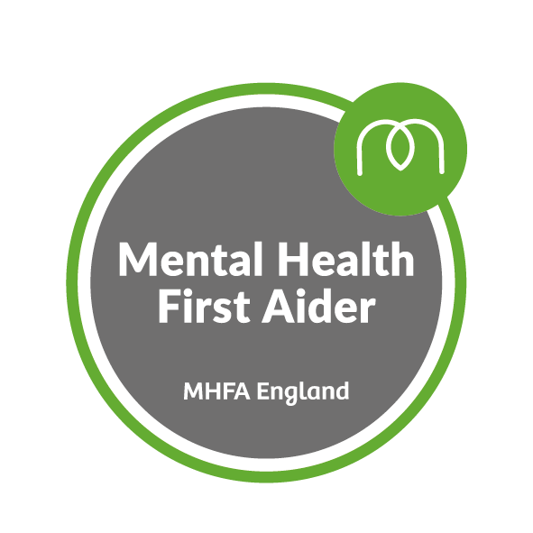**LOROS Mental Health First Aiders**

|  |  |
| --- | --- |
| Compassionate Neighbours | Brenda Wilford |
| Corporate/ management | Caroline Baker, Claire Brown, Rebecca Stevens |
| Education | Mel Stacey |
| Enterprises | Lindsey Gilbert, Lynda Spicer, Sam Glover, SJ Waites, Steph Hiom, Vicki Mayfield |
| Fundraising | Emma Jones |
| HR | Emma Gilliver |
| IT | Lisa Andrews |
| Lotteries | Dianne Noon |
| Lymphoedema | Coline Morris |



There are plenty of different types of support out there, and a Mental Health First Aider can help you access them. Mental Health First Aiders are a point of contact if you, or someone you are concerned about, are experiencing a mental health issue or emotional distress. They are not therapists or psychiatrists but they can give you initial support and signpost you to appropriate help if required.

**If you have any questions about Mental Health First Aid at LOROS contact the Mental Health First Aiders directly or email**

[**hr@loros.co.uk**](mailto:hr@loros.co.uk)

**You can also contact someone from the Chaplaincy department at ANY time. Ext 8411 or please go to the Chaplaincy office next to the dining room.**

Training provided by MHFA England