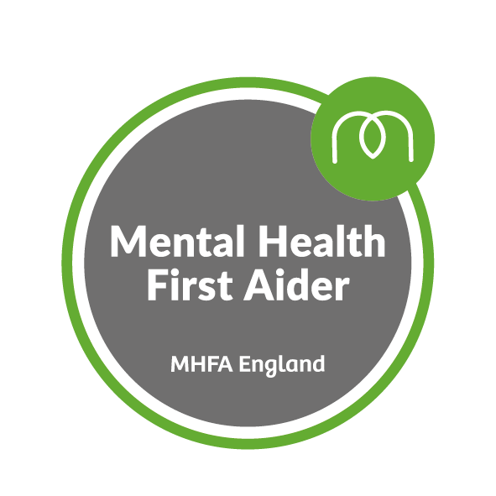
LOROS Mental Health First Aiders

Bereavement Support | Suzann Chantrill
Compassionate Neighbours | Brenda Wilford
Corporate/ management | Rebecca Stevens, Jo Kavanagh
CRM/ Supporter Care | Lisa Clarke
Day Therapy | Beth Tomlinson
Enablement | Helen Holland
Enterprises | SJ Waites, Angie Skelton, Samm Norman, Vicki Mayfield, Mary Lockhart. Gary Macmillan-Dale, Ady Bryan, Lindsey Gilbert
Fundraising | Alison Pettit
HR | Emma Gilliver
Lotteries | Dianne Noon
Ward | Mary Hartfield

There are plenty of different types of support out there, and a Mental Health First Aider can help you access them. Mental Health First Aiders are a point of contact if you, or someone you are concerned about, are experiencing a mental health issue or emotional distress. They are not therapists or psychiatrists but they can give you initial support and signpost you to appropriate help if required.
If you have any questions about Mental Health First Aid at LOROS contact the Mental Health First Aiders directly or email
hr@loros.co.uk
staffnetwork@loros.co.uk

Training provided by MHFA England

