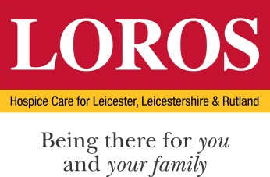

JOB DESCRIPTION

JOB TITLE: Domestic Assistant

ACCOUNTABLE TO: Area Manager

RESPONSIBLE TO: Shop Manager

HOURS: As per Contract

ROLE PROFILE: To provide a comprehensive cleaning service as detailed within the Cleaning Specifications for the buildings within the premises, to enhance the experience received by our customers, visitors and staff on site.

ROUTINE DUTIES:

DOMESTIC ROUTINE DUTIES:

- Be fully conversant with the Cleaning Policy 9.40, to enable you to safely carry out all domestic duties in line with the Cleaning Work Schedules for the site; so all daily, weekly, other periodic duties are carried when due.

- Be trained to work to and follow technical cleaning method statements

- Ensure your personal Cleaning Staff Training Record is up to date and signed off by one of the approved trainers.

- Refer to as necessary the cleaning folder (copy in each cupboard) of all cleaning work schedules, technical method statements and risk assessments, where necessary seeking advice from the Team Leader.

- Be trained to use all work equipment and the control of substances hazardous to health (COSHH)

Additional Duties:

- To ensure that all areas are maintained to a high standard of cleanliness.
- To be courteous and helpful to all patients, relatives, visitors and other members of staff.
- To abide by the Health and Safety at Work Act and attend training courses – mandatory and essential for role, as required.
- To maintain confidentiality regarding visitors and customers at all times.

GENERAL:
All staff are subject to Equal Opportunities Legislation, the Data Protection Act and LOROS Confidentiality Policy.
To carry out and comply with the prevention and control of infection as per LOROS policies and procedures.
All staff are subject to LOROS policies, procedures and conditions of service, with reference to the Health and Safety at Work Act 1974.

The post holder is responsible for safeguarding the interests of children and adults who they come into contact with during their work. To fulfil these duties post holders are required to undertake mandatory training to recognise the signs and symptoms of abuse, or neglect, or individuals at risk and to follow LOROS policies relating to safeguarding practice including reporting any concerns that they may have.
Take reasonable care for the health and safety of themselves and of other persons who may be affected by their acts or omissions at work.
Co-operate with their employer as far as is necessary to meet the requirements of the legislation.
All staff should be aware of and aim to contribute to LOROS’ Vision and Mission and also strive to exhibit the Values & Behaviours at all times (see attached document).
The contents of this job description are not exhaustive and may be amended in accordance with the needs of the service after discussion with the post holder whose agreement will not be unreasonably withheld.

Signed………………………………………………………… Date…………………………………………
Postholder

Signed……………………………………………………….. Date ………………………………………..
Line Manager
