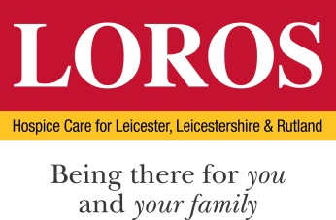

PERSON SPECIFICATION

POST: Anstey Café & Catering Manager

DEPARTMENT: Catering

 | Essential Criteria | Desirable Criteria | How & When
Education / Qualification | - Minimum NVQ Level 1 in hospitality & catering and/or professional cookery OR proven experience of working in a similar role  - GCSE grade C or above or equivalent  - Health and Safety and L2 Food Hygiene or Equivalent | - Level 2/3 NVQ in Hospitality & Catering  - Train the Trainer  - Aspiring leadership training  - Customer service training  - L3 Food Hygiene | Certificates/  Application
Skills / Abilities | - Ability to inspire your team to deliver best service possible  - Ability to stay calm under pressure  - Quality Food Production  - Understanding of produce and ingredients  - Stock Control  - First Class Customer Service  - Flexible in your approach and have the ability to work on own initiative  - Able to implement systems and consistent standards to manage quality of product and service  - Good Oral and Written Skills  - IT Skills Excel/Word/E Mail | - Team player  - Proven customer service skills  - Ability to write menus that are both creative and profitable  - Ability to cost a menu and produce selling prices in line with the GP target | Application  Interview/ Assessment Centre  References
Experience | - Managing Staff  - Good food knowledge  - Cash Handling  - Be able to demonstrate experience in a food retail environment. | - Experience within a high street coffee outlet advantageous.  - Barista trained  - Budgeting of food costs | Application  Interview/ Assessment Centre  References
Knowledge | - Dietary and Allergen awareness  - COSHH awareness and understanding |  | Interview/ Assessment Centre
Motivation and personal attributes | - Able to contribute to LOROS’ Values & Behaviours  - Passion for cooking  - A warm personality with a happy, welcoming approach to customer service both with internal and external customers  - Strong work ethic  - Team minded  - Solution focused  - Organised |  | Interview/ Assessment Centre

