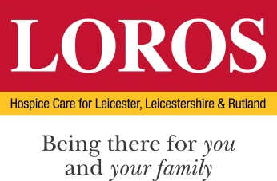

SELECTION CRITERIA

POST: Head of Retail
DEPARTMENT: LOROS Enterprises
 | Essential Criteria | Desirable Criteria | How & When
Education / Qualification | Good standard of education which should include GCSE Grades A to C in English and Maths or equivalent. | HNC or above.  City and Guilds Award Certificate/Diploma in Retail Skills or equivalent.  HR qualification.  Management qualification  e.g. ILM or equivalent. | Application  Certificates
Skills / Abilities | Competent IT skills and use of Excel, PowerPoint and Word.  Excellent communication and interpersonal skills.  Ability to build and maintain an effective team.  Able to prioritise work and meet deadlines.  Able to motivate self and others.  Strong and proven leadership skills. | Flexible and adaptable to changing needs of business.  Able to work across multiple departments. | Assessment Centre  Application  References
Experience | Proven experience of achievement in a retail environment.  Experience of managing and achieving budgets and/or targets.  Proven experience of successfully managing or leading a team.  Managing performance.  Multi-site management.  High-turnover management.  Stock control | Experience of setting budgets / targets.  Experience of writing and implementing strategies. Charity retail experience.  Proven experience of being involved or leading on service improvements.  Cross department working.  Opening of new retail sites.  Stock ordering/ management.  Volunteer management. | Assessment Centre  Application
Knowledge | Current trends/ shopping habits.  Leicester, Leicestershire and Rutland.  Retail knowledge. | Knowledge of LOROS.  Maintenance of sites.  Charity retail knowledge. | Assessment Centre  Application

