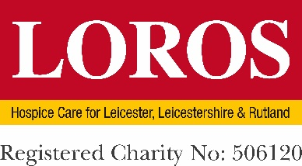

GIFT AID DECLARATION – (Cash/Debit Card/Cheque)

for past, present and future donations

Please complete and return to: LOROS Supporter Care Team, Groby Road, Leicester, LE3 9QE.
Or complete online here:- www.loros.co.uk/ways-to-donate/gift-aid-your-donation

Details of Donor -
Under new HMRC rules, we must have a full First Name & Surname in order to activate a declaration

Title: …………………… First name/s: ………………………………… Surname: …………………………………

Address: …………………………………………………………………………………………………………………………………

………………………………………………………………………………………. Postcode: …………………………………

Contact number: ……………………………………… Email: ……………………………………………………………
*By providing your email address you can help us to save money on postage. Thank you.

Donation amount: …………………………… ID (Office use only): …………………………………

I am a UK tax payer

I would like LOROS to treat this donation, any donations I make in the future and any I have made in the past 4 years as Gift Aid donations. I am a UK taxpayer and understand that if I pay less Income Tax and/or Capital Gains Tax than the amount of Gift Aid claimed on all my donations in that tax year it is my responsibility to pay any difference. I understand that LOROS will reclaim 25p of tax on every £1 that I give.

Signed: ……………………………………………………… Date: .……………/………………/……………

We will be able to claim Giftaid if this is your personal money and does not depend on receiving goods in return.

Yes, this donation is my personal money.

No, this is money that I have collected from others.

Please notify the charity if you:

- Want to cancel this declaration
- Change your name or home address
- No longer pay sufficient tax on your income and/or capital gains.

If you pay Income Tax at the higher or additional rate and want to receive the additional tax relief due to you, you must include all your Gift Aid donations on your Self Assessment tax return or ask HM Revenue and Customs to adjust your tax code.

