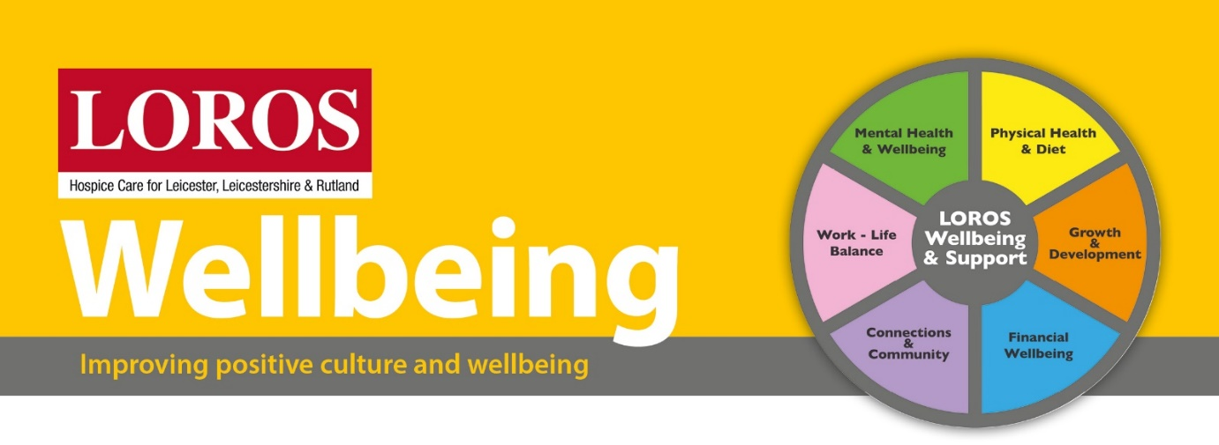
LOROS Wellbeing Champions

Our staff and volunteers told us wellbeing was important to them and we want to make sure we have enough support in place to honour that.
We already have a wellbeing coordinator and now we are building a network of wellbeing champions from each department. The champions will be the point of contact within their teams but will also work alongside the coordinator to communicate wellbeing initiatives and signpost when needed.
What will you be a champion of?
There are 6 zones of wellbeing in our strategy:
- Mental health and wellbeing
- Connections and community
- Growth and development
- Physical health and diet
- Work- life balance
- Financial wellbeing
You will help communicate each of these zones throughout the year with the support of the wellbeing coordinator.
How will you do it?
You will attend quarterly meetings with the wellbeing coordinator as well as keeping in contact through the year. You will be the wellbeing advocate in team meetings and give any feedback or thoughts to the coordinator. You will take ideas, research them and discuss their progress with the wellbeing coordinator, who will then gain permission for you to develop them.
How much time will it take?
Each quarterly meeting will be 1 hour, so a maximum of 4 hours over a 12 month period. When there is an event linked to wellbeing it would be great for you to take part in as many as you can. Any additional time you would like to put in to either talk about wellbeing within your team or take part in more events would then be up to yourself and your line manager.
Who can support you?
Your line manager is always available to support you as is the wellbeing coordinator and any member of the HR team. Whilst you are supporting others with their wellbeing, you should also remember yourself.
Why is all of this important?
Having a wellbeing champion in each department means that we will get a better insight into what works best for each team. We all have individual needs but we also have collective team needs that can differ. It is important that we recognise this and use this insight to make improvements. It also means wellbeing stays on the agenda within your teams.
What next?
Speak to your Line Manager to let them know you would like to do this then email louisekiernan@loros.co.uk I will then contact you with a date when we can all meet to discuss the plans for wellbeing and how you can help. As a team it is important to get as many views as possible and I look forward to moving wellbeing at LOROS even further forward by including you in the decisions we make.

