Our International Charity for the 8th  year is Mary’s Meals.  Hunger is the major obstacle that prevents child-ren from obtaining an education. Their priority is  to obtain money to buy food and survive. Many children search through dangerous rubbish  dumps to find items that they may be able to sell. Yet education is their only way out of poverty.  Mary’s Meals provides a daily meal in a place of education for more than 3 million children  in some of the world’s poorest communities.  Mary’s Meals is working in 16 countries across Africa, Asia, Eastern Europe, Middle East, Latin America and the Caribbean.  Through the Swimarathon we sponsor every child attending Kasupe Primary School in Chipata, Zambia.  43% of Zambia’s population is under the age  of 14. 57% of the population live on around £1  per person per day. There is a 45% drop-out  rate from Primary School. There are high rates  of poverty, malnutrition and food insecurity.    Since 2018 we have provided every child at Kasupe Primary School with a daily meal  made with locally grown maize & soya porridge fortified with vitamins and minerals. As a result, pupil numbers increased from 266 in 2018 to  405 in 2025.  Fun with a purpose !  The Swimarathon has been our major fund-  raising event for local, Leicestershire and  Rutland charities as well as supporting our international projects.  Our 9 previous Swimarathons have made 66 donations totalling £29,200 to 26 charities:  Birkett House School (x7)  Rainbows (x7)  One Roof Leicester (x7) )  Leicester Children’s Holiday Centre  (Mablethorpe ((x3) & Leicester Children’s  Holidays (x3)  Hope Against Cancer (x6)  Leicester, Leicestershire & Rutland Blood Bikes (x4)  Community First Responders (x4)  Leicestershire MS Therapy Centre (x2)  The Carers Centre Leicestershire & Rutland (x2)  Loros (x2)  Action Homeless (x2)  The Bridge (x2)  Menphys (x3)  East Midlands Immediate Care Scheme (EMICS) Women’s Aid Leicester  Focus  Healing Little Hearts  Ash Field Academy  Help the Homeless  Age UK Oadby & Wigston  Peter Le Marchant Trust  Warning Zone  Air Ambulance Service  The Laura Centre  .  In addition the Swimarathons raised:  £18,400for our International Projects  £5,300 for our General Purposes Fund (for disaster relief etc whether in the UK or overseas). | 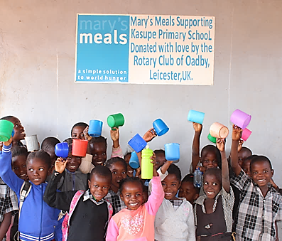  “This porridge is satisfying when I eat it and I  feel bad if I don’t. When I eat I stay quiet in  class and concentrate. I am usually number  one in class because of this porridge. I want to help my mother and my father because both  don’t work.” Student – Moses, age 9  During 2025- 2026, we will have provided a total of more than  half a million meals  Your support is vital in this exciting  venture. You will be inspiring dreams and will give these children a real  hope of a future.  You select the charity or  worthy cause you wish  to support!  Instead of us selecting charities to support, your team selects a charity or worthy cause even if you are a charity swimming on behalf of your- selves.  Your team will receive from us 60% of all monies you raise including 60% of any applicable Gift Aid. The remaining 40% go to the Rotary Club of Oadby Charitable Trust and fund our current International Project and General Purposes Fund.  This is a significant fund-raising opportunity for a cause that may be close to your heart and one that you are keen on supporting  Some statistics!  In our 9 previous Swimarathons:  181 teams  800 swimmers  257 miles swum  That’s the distance from  Leicester to Glasgow! | Come & Have Fun!  The Rotary Club of Oadby’s  10th Annual Swimarathon  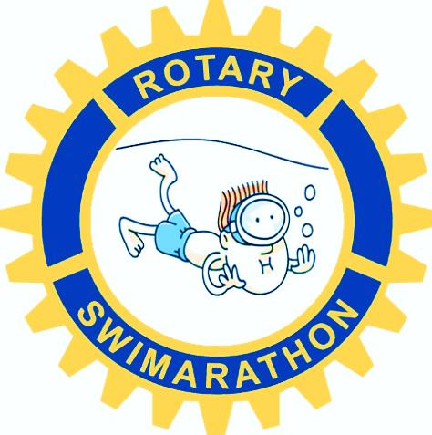  at  Parklands Leisure Centre  Sunday 29th March 2026  Supporting local charities and worthy causes in our  community and raising funds  towards our international  projects  For further information please contact  swimarathon@oadbyrotary.org.uk  Rotary Club of Oadby Charitable Trust  (Registered № 1081136)  It’s a community event!  Teams of 2 to 6 swimmers are invited to enter.  Or why not have 2 teams! Teams can be  entered by schools, clubs, local firms,  supermarkets, groups and especially by the  charities themselves. Each team is co-ord-  inated by its Team Leader. There is no age  restriction. However, any team of swimmers  under 14 years of age must have an adult in  charge (not necessarily in the water). Individ-  ual swimmers should obtain as much  sponsorship as they can from family and  friends. (All expenses are covered by  Business Sponsorship).  There will be music playing!  The Swimarathon is not a race or a distance  endurance test. Each team will have the sole  use of one lane for a specified 55 minutes.  Team members swim in relay for as few or as  many lengths as they wish. Lengths are  counted and announced every 15 minutes.  Teams are encouraged to bring supporters to  loudly cheer them on in their efforts.  It will be a fantastic occasion!  Each swimmer receives a certificate as well as  a “little something” for taking part. Most  participants are keen to return and swim  in our Swimaratrhon the following year.  Business Sponsorship gives local business-  es the opportunity to thank the community by  supporting the efforts of our swimmers. For  information about the levels of sponsorship  and how we promote your support, please  contact us via our email address.
  £19.15
  will feed a child
  for a whole school year!
  Since our first Swimarathon in 2016, you have raised an amazing £52,900 !

