EasOur International Charity is Mary’s Meals.  Hunger is the major obstacle that prevents child-ren from obtaining an education. Their priority is  to obtain money to buy food and survive. Many children search through dangerous rubbish  dumps to find items that they may be able to sell. Yet education is their only way out of poverty.  Mary’s Meals provides a daily meal in a place of education for more than 2 million children  in some of the world’s poorest communities.  Mary’s Meals is working in 17 countries across Africa, Asia, Eastern Europe, Middle East, Latin America and the Caribbean.  Through the Swimarathon we sponsor  Kasupe Primary School in Chipata, Zambia.  43% of Zambia’s population is under the age  of 14. 57% of the population live on around £1  per person per day. There is a 45% drop-out  rate from Primary School. There are high rates  of poverty, malnutrition and food insecurity.    Since 2018 we have provided every child at Kasupe Primary School with a daily meal  made with locally grown maize & soya porridge fortified with vitamins and minerals. As a result, pupil numbers increased from 266 in 2018 to  331 in 2024.  During 2025-26 we will provide our 500,000th meal for Kasupe School.  The Swimarathon has been our major fund-  raising event for local, Leicestershire and  Rutland charities as well as supporting our international projects.  Fun with a purpose !  Our 8 previous Swimarathons have made 62 donations totalling £27,700 to 24 charities:  Birkett House School (x7)  Rainbows (x7)  One Roof Leicester (x7) )  Leicester Children’s Holiday Centre  (Mablethorpe ((x3) & Leicester Children’s  Holidays (x3)  Hope Against Cancer (x6)  Leicester, Leicestershire & Rutland Blood Bikes (x4)  Community First Responders Oadby/Wigston (x3)  Leicestershire MS Therapy Centre (x2)  The Carers Centre Leicestershire & Rutland (x2)  Loros (x2)  Action Homeless (x2)  The Bridge (x2)  Menphys  East Midlands Immediate Care Scheme (EMICS) Women’s Aid Leicester  Focus  Healing Little Hearts  Ash Field Academy  Help the Homeless  Age UK Oadby & Wigston  Peter Le Marchant Trust  Warning Zone  Air Ambulance Service  The Laura Centre  .  In addition the Swimarathons raised:  £16,200 for our International Projects  £4,900 for our General Purposes Fund (for disaster relief etc whether in the UK or overseas). | 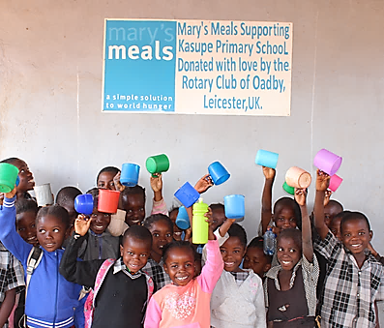  “This porridge is satisfying when I eat it and I  feel bad if I don’t. When I eat I stay quiet in  class and concentrate. I am usually number  one in class because of this porridge. I want to help my mother and my father because both  don’t work.” Student – Moses, age 9  It costs just £19.15 to feed a child for  a whole school year!  The difference one individual can make is profound…  “From my own fundraising I would like to  donate £1,000 towards supporting Kasupe School in Zambia. With love.” William, age 9  … providing 50 pupils with 10,000 meals  Your support is vital in this exciting  venture. You will be inspiring dreams and will give these children a real  hope of a future.  You select the charity or  worthy cause you wish  to support!  Instead of us selecting charities to support, your team selects a charity or worthy cause even if you are a charity swimming on behalf of your- selves.  Your team will receive from us 60% of all monies you raise including 60% of any applicable Gift Aid. The remaining 40% go to the Rotary Club of Oadby Charitable Trust and fund our current International Project and General Purposes Fund.  This is a significant fund-raising opportunity for a cause that may be close to your heart and one that you are keen on supporting  Some statistics!  Since our first Swimarathon in 2016, you have raised an amazing £48,800 !  In our 8 previous Swimarathons:  162 teams  725 swimmers  234 miles swum  That’s further than  driving from Leicester to Cardiff  and back. | Come & Have Fun!  The Rotary Club of Oadby’s  9th Annual Swimarathon  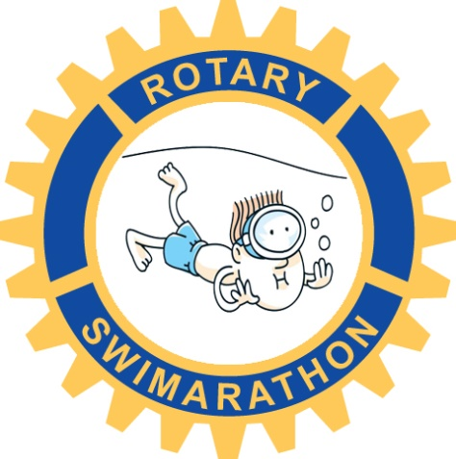  at  Parklands Leisure Centre  Sunday 6th April 2025  Supporting local charities and worthy causes in our  community and raising funds  towards our international  projects  For further information please contact  swimarathon@oadbyrotary.org.uk  Rotary Club of Oadby Charitable Trust  (Registered № 1081136)  It’s a community event!  Teams of 6 (+ or -) are invited to enter our  Swimarathon. Teams can be entered by  schools, clubs, local firms, supermarkets,  groups and especially by the charities them-  selves. Each team is co-ordinated by its Team  Leader. There is no age restriction. However,  any team of swimmers under 14 years of age  must have an adult in charge (not necessarily  in the water). Individual swimmers should  obtain as much sponsorship as they can from  family and friends. (All expenses are covered  by Business Sponsorship).  There will be music playing!  The Swimarathon is not a race or a distance  endurance test. Each team will have the sole  use of one lane for a specified 55 minutes.  Team members swim in relay for as few or as  many lengths as they wish. Lengths are  counted and announced every 15 minutes.  Teams are encouraged to bring supporters to  loudly cheer them on in their efforts. A  competitive element can develop!  It will be a fantastic occasion!  Each swimmer receives a certificate as well as  a “little something” for taking part.  Most participants are keen to return and swim  in our Swimaratrhon the following year.  Business Sponsorship gives local business-  es the opportunity to thank the community by  supporting the efforts of our swimmers. For  information about the levels of sponsorship  and how we promote your support, please  contact us via our email address.

