
Within specialist palliative care we sometimes use medication that is classed as ‘unlicensed’. This may mean the medication is officially used for other conditions, but it has been specially prepared for you by a pharmacist or is being used in an unusual way, for example crushing a tablet to make it easier for you to swallow. You may be prescribed a medicine to treat a symptom for which the product is not licensed.

Medicines are marketed to treat specific conditions but often help to relieve other symptoms as well; for example, some medicines that are licensed to treat epilepsy also relieve nerve pain. Using certain drugs to treat complex symptoms is quite common in palliative care but can cause some confusion when patients or carers read information leaflets which refer only to the licensed conditions.

Sometimes when medications are no longer manufactured in the UK or there are problems with the supply chain within the UK, you may be given medication we have ordered from another country. These are of the usual high quality, having a license in that country, but are classified as ‘unlicensed’ as they would not hold a UK license for use.

You will only be prescribed a medicine outside its licensed conditions if the doctor considers it to be appropriate and necessary. If you have any concerns about this then a doctor, nurse or our pharmacy team would be pleased discuss this with you.

The Pharmacy team are onsite at LOROS or can be contacted on 0116 2318482.

This leaflet is updated regularly. For the most up to date information please visit https://loros.co.uk/our-care.

In cases of comments or complaints, please contact:
Chief Executive, or Director of Care Services, LOROS, Groby Road, Leicester LE3 9QE or, Care Quality Commission, East Midlands Office, Citygate, Gallowgate, Newcastle Upon Tyne NE1 4PA

Unlicensed Medicines
This factsheet is for guidance only and has been produced with assistance from healthcare professionals

We hope to answer your concerns, but if you have any more questions please ask a member of staff
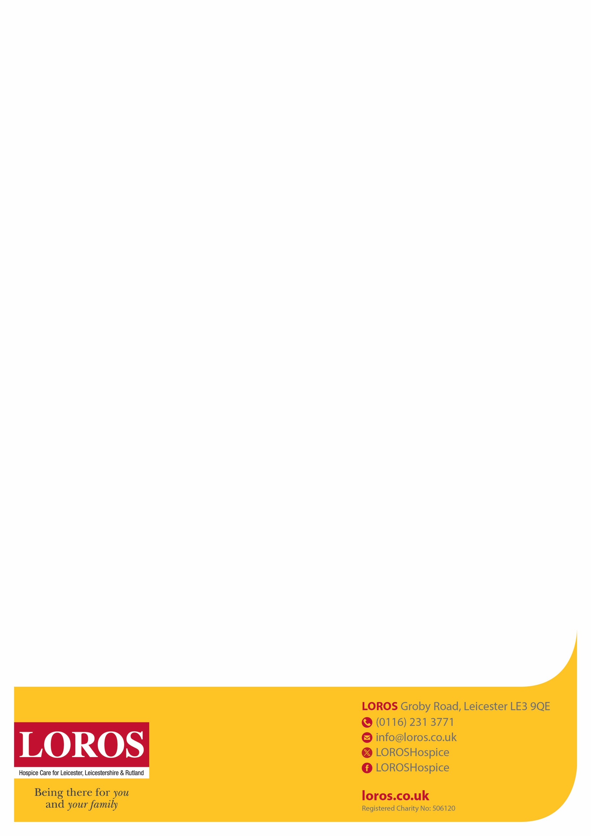
If you would like this information in another language or format, please telephone
0116 231 8435 or email info@loros.co.uk

اگر آپ یہ معلومات کسی دوسری زبان یا فارمیٹ جیسے ایزی ریڈ یا بریل میں چاہتے ہیں تو براہ کرم 0116 231 8435 پر ٹیلی فون کریں یا info@loros.co.uk پر ای میل کریں

ਜੇਕਰ ਤੁਸੀਂ ਇਹ ਜਾਣਕਾਰੀ ਕਿਸੇ ਹੋਰ ਭਾਸ਼ਾ ਜਾਂ ਫਾਰਮੈਟ ਵਿੱਚ ਚਾਹੁੰਦੇ ਹੋ ਜਿਵੇਂ ਕਿ ਈਜ਼ੀ ਰੀਡ
ਜਾਂ ਬ੍ਰੇਲ, ਕਿਰਪਾ ਕਰਕੇ 0116 231 8435 'ਤੇ ਟੈਲੀਫ਼ੋਨ ਕਰੋ ਜਾਂ info@loros.co.uk 'ਤੇ ਈਮੇਲ ਕਰੋ

Jeśli chcesz uzyskać te informacje w innym języku lub formacie, np. Easy Read
lub Braille'a, zadzwoń pod numer 0116 231 8435 lub wyślij e-mail na adres info@loros.co.uk

